POSITION PAPER

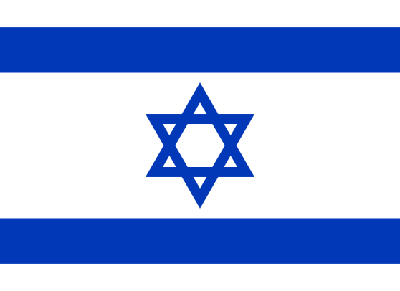
NAME OF THE DELEGATE: Ananya Sharma
COMMITTEE: United Nations Human Rights Council
COUNTRY: Israel
AGENDA: Human Rights Violation due to Israeli-Palestinian Conflict.

The Israeli-Palestinian conflict dates back to the end of the nineteenth century, primarily as a conflict over territory. After the 1948 Arab-Israeli war, the Holy Land was divided into three parts: the State of Israel, the West Bank (of the Jordan River), and the Gaza Strip. Successive wars resulted in minor shifts of territory until the Yom Kippur War in October 1973.
Israel is actively working to support reconstruction efforts in the Gaza Strip. This reconstruction mechanism includes provision of 2.5 million tons of construction material, rebuilding of 2,733 homes, repair of 100,513 homes in the process and 241 international large scale projects under construction.
Israel signed a series of peace agreements aimed at creating a Palestinian state beside Israel. In the interest of peace, Israel took a risk that Yasser Arafat, who for decades had led a terror campaign against Israeli civilians, had chosen the path of peace. Israel agreed to withdraw from parts of the West Bank and Gaza Strip and arm a Palestinian police force — and did so — even though Arafat did not fulfill his promises to recognize Israel's right to exist, renounce terrorism, negotiate disputes, and confiscate illegal weapons.
Israel captured the West Bank defending itself after being attacked by Jordan. Still, Israel offered to trade most of this land for peace. It took 25 years before the Palestinians said they would accept this deal, but after Israel withdrew from almost all the Gaza Strip and nearly half the West Bank, the Palestinians have not given Israelis any peace, only terror.

