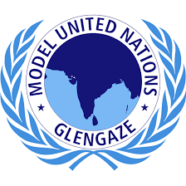
GLEN GAZE MODEL UNITED
NATIONS

United Nations Economic and Social Council
(ECOSOC)

AGENDA: Impact of corona virus on international trade and strategies made for post corona situation.
LETTER FROM THE EXECUTIVE BOARD

Greetings

We welcome you to the United Nations Economic and Social Council of Covid 19 Glen Gaze online mun in the capacity of the members of the Executive Board of the said conference. Since this conference shall be a learning experience for all of you, it shall be for us as well. Our only objective shall be to make you all speak and participate in the discussion, and we pledge to give every effort for the same.

How to research for the agenda and beyond? There are several things to consider. This background guide shall be different from the background guides you might have come across in other MUNs and will emphasise more on providing you sources where you find matter for your research than to provide you matter itself, because we do not believe in spoon-feeding you, nor do we believe in leaving you to swim in the pond all by yourself. However, we promise that if you read the entire set of this document, you shall be able to cover 70% of your research for the conference. The remaining amount of research depends on how much willing are you to put in your efforts and understand the whole agenda of the committee.So, in the purest of the language we can say, it is important to read anything provided in the background guide.

What to speak in the committee and in what manner? The basic emphasis of the committee shall not be on how much facts you read and present in the committee but how you explain them in simple and decent language to us and the fellow committee members. The entire conference aims at analysing your understanding of the agenda and not how much you have studied. So, kindly focus upon analysis and explanation, because we are interested in knowing how much you know and remember that you will know only if you read and work. We wish you all the very best and feel free to ask doubts, if any.

Smriti Shukla(Chairperson)

Smritishukla2303@gmail.com

Saumya Mittal (Vice Chairperson)

mittalsaumya01@gmail.com

ABOUT THE COMMITTEE
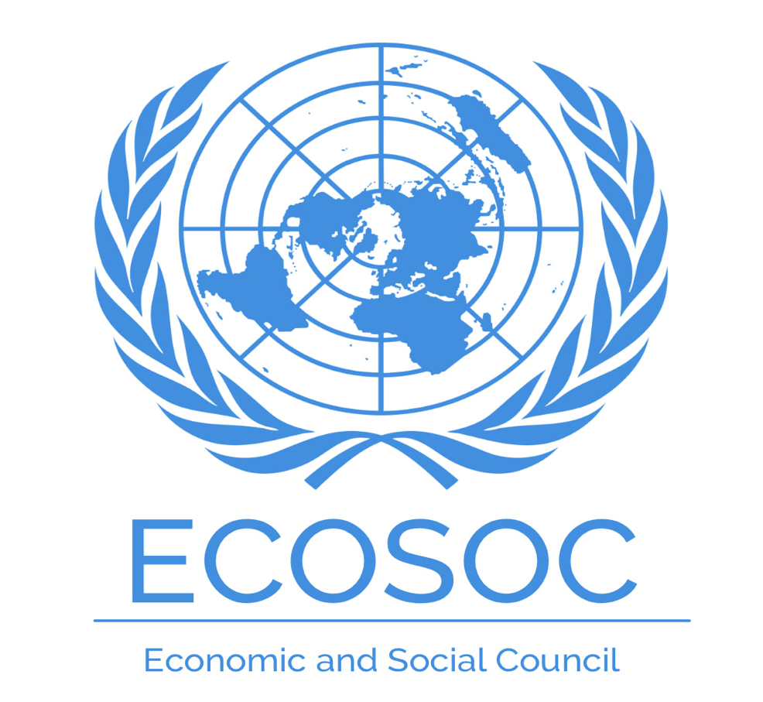

The Economic and Social Council is at the heart of the United Nations system to advance the three dimensions of sustainable development – economic, social and environmental. It is the central platform for fostering debate and innovative thinking, forging consensus on ways forward, and coordinating efforts to achieve internationally agreed goals. It is also responsible for the follow-up to major UN conferences and summits.
The UN Charter established ECOSOC in 1945 as one of the six main organs of the United Nations.
Coordination within the UN
ECOSOC links a diverse family of UN entities (Organigram) dedicated to sustainable development, providing overall guidance and coordination. The entities include regional economic and social commissions, functional commissions facilitating intergovernmental discussions of major global issues, and specialised agencies, programmes and funds at work around the world to translate development commitments into real changes in people’s lives.
Reforms over the last decade, particularly General Assembly resolution 68/1, have strengthened ECOSOC’s leading role in identifying emerging challenges, promoting innovation, and achieving a balanced integration of the three pillars of sustainable development—economic, social and environmental. ECOSOC is charged with giving special attention to coordinated follow-up on major UN conferences and summits
Partnership with the rest of the world
Building on its coordination role within the UN system, ECOSOC is a gateway for UN partnership and participation by the rest of the world. It offers a unique global meeting point for productive dialogues among policymakers, parliamentarians, academics, foundations, businesses, youth and 3,200+ registered non-governmental organisations.
A spotlight on global issues
Each year, ECOSOC structures its work around an annual theme of global importance to sustainable development. This ensures focused attention, among ECOSOC’s array of partners, and throughout the UN development system. By emphasising combined economic, social and environmental concerns, ECOSOC encourages agreement on coherent policies and actions that make fundamental links across all three.
ECOSOC’s annual High-Level Segment includes:
• High-Level Political Forum provides political leadership, guidance and recommendations for sustainable development, and reviews progress in implementing sustainable development commitments
• Development Cooperation Forum reviews trends and progress in development cooperation

About The Agenda

Impact Of Corona Virus On Global Trade:
The Covid-19 virus is severely affecting international trade, creating a negative economic outlook. Consequently, the global economy is receiving its sharpest reversal since the Great Depression, IMF warns. “This is a crisis like no other,” suggests Kristalina Georgieva, Managing Director of the International Monetary Fund (IMF). “Never in the history of the IMF have we witnessed the world economy coming to a standstill,” she said. “It is way worse than the global financial crisis.”

Georgieva’s comments are supported by worrying fiscal data that shows the number of Americans seeking unemployment benefits hit a record high for the second week in a row. More than 6.6 million filed jobless claims in the week ended March 28, according to the Department of Labor.

Three Severe Implications Of Covid19 On Global Trade:
1.It’s much harder to repurpose supply chains than people assume:
Uncertainty is the biggest hurdle for businesses because it impedes their ability to plan and commit financial and human resources to specific projects and keep their costs low. They do their best to predict demand for several months in advance. But it is hard to do that now because supply chains are so global. For those businesses fortunate enough to have increased demand, say, ventilators, and medical supplies manufacturers, ramping up production is not at all simple.

However, the most significant challenges lie in the inherent weaknesses of the distribution and logistics aspects of supply chains. Logistics and distribution are very people-intensive. One cannot load ships, inspect goods, drive trucks, trains without people. We know that a good percentage of these people are unable to work because they are not considered essential or are infected. Even when they are not, there may be restrictions on their movement. In short, while there may be goods available for purchase (for instance, China has plenty of PPE supplies), but how do you get them to where they are needed, in Europe or America?

2.Nationalism will rise, and continue to rise:
We’ve seen some governments take action to block the export of items they deem critical. Therefore, it’s likely will see more and more nationalism when it comes to what individual governments regard to be essential resources and goods for their populations. We have seen the issue of food security. Countries such as Kazakhstan, Serbia, and Morocco have acted to secure food supplies and have sought to limit exports of critical staples, such as wheat, rice among others. Nationalism extends to the broader concept of ‘national security’. As such, we are seeing several countries invoke restrictions or taking action to secure medical supplies. India has banned the export of ‘key’ medicines, from as simple things as paracetamol to face masks and chloroquine. The U.S. has threatened to nationalize key firms making medical equipment, on the grounds of national security, invoking wartime powers, because, as Trump argues, ‘we are at war’ which extends beyond U.S. borders.

3.There will be harsh consequences of Governments moving to prevent exports:
If the U.S. acts to nationalize firms, redirect orders, or restrict exports, the E.U. will follow suit. However, the E.U. and the U.S. have enough economic power that they will probably work out some deal. One should worry most about developing countries without any domestic suppliers, who also need critical medical supplies, and who will be locked out, and not access essential equipment, medicines, and basic foodstuffs because of export restrictions in the developed countries. We already see a 5-fold rise in prices for medical supplies, and it will be hard for poorer countries to afford them.

Strategies Made For Post Corona Situation:

Despite considerable uncertainty, there are four actions that can be taken now:

First, boost confidence in trade and global markets by improving transparency:
A strong, shared, transparent information base is critical in underpinning sound national policy responses and the international co-operation to keep trade flowing. It will be critical that countries honour their commitments to notify trade-related measures taken in response to COVID-19 to the World Trade Organisation (WTO). The OECD is sharing information on trade-related country actions on COVID-19 with WTO colleagues, and assessing the likely impact of these actions to help support policy makers dealing with the crisis.

Second, keep global supply chains going, especially for essentials:
An important priority is keeping the key supply chains for essential goods for the crisis – including medical supplies, food products and ICT goods and services – open and functioning. However, we are starting to see a number of challenges to keeping these supply chains going related to the business of trade.

Third, avoid making things worse:
There are many unavoidable costs in the current pandemic; all the more reason to avoid actions that add to costs for traders and consumers. Chief among these is the need to avoid export restrictions on essential goods, such as medical equipment and, especially, food products. Currently, more than 60 countries3 have restricted exports of essential goods and increasingly agriculture and food products.
The lesson of the food price crisis of 2007-08 is that export restrictions are a recipe for self-inflicted harm, undermining food security for everyone. Experience has shown that export restrictions temporarily lower domestic prices and raise availability, but they also discourage domestic production and so any benefit tends to be short-lived.

Fourth, look beyond the immediate: Policy actions now could have a long life:
While countries are necessarily focused on ensuring the health and economic security of their people today, the OECD can play a particularly important role in looking ahead and, in light of past and current experiences, contribute to helping governments ensure a recovery that is robust, widespread, and sustainable.
Some links that will help the delegates to understand the agenda better are given below.
Do not forget this background guide is just to help you out there are so many sub topics that are not mentioned in it.
Do your research well, read, understand and speak well in the committee.
~note from the chairperson
(smriti shukla)

Links to help you out:

https://www.thehindubusinessline.com/opinion/columns/c-p-chandrasekhar/covid-19-adds-new-dimensions-to-us-china-trade-war/article31616385.ece/amp/

https://www.ftadviser.com/investments/2019/10/15/how-is-the-us-china-trade-war-affecting-the-global-economy/

https://foreignpolicy.com/2020/04/17/globalization-trade-war-after-coronavirus-pandemic/

https://unctad.org/en/pages/newsdetails.aspx?OriginalVersionID=2363

In case of any doubt delegates may feel free to contact
Smriti Shukla (chairperson of ECOSOC) (9999628196)
Saumya Mittal (Vice chairperson of ECOSOC) (8800954731).

