GLEN GAZE
MODEL UNITED NATIONS

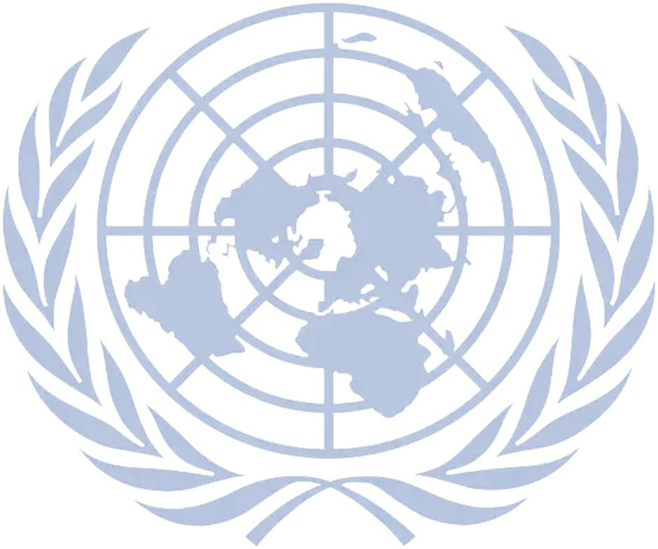

2020
SECURITY COUNCIL

BACKGROUND GUIDE

GLEN GAZE MODEL UNITED NATIONS SECURITY COUNCIL BACKGROUND GUIDE

LETTER FROM THE EXECUTIVE BOARD

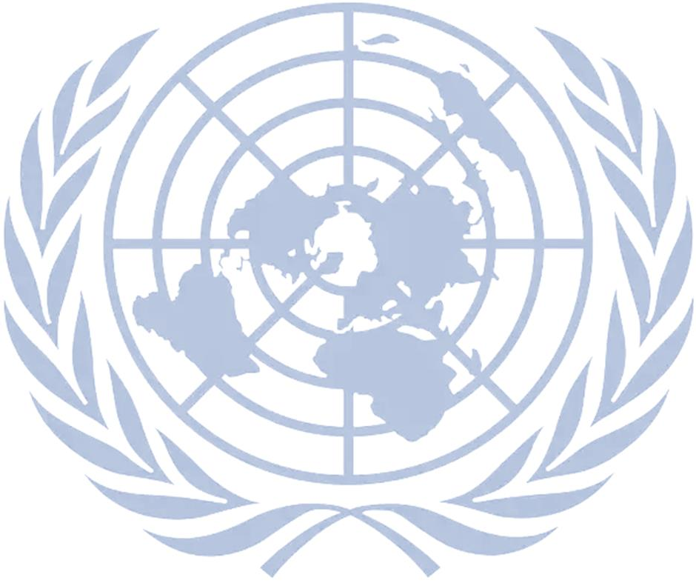
Respected Delegates,
We are pleased welcome you to this simulation of the Security Council. First things first, our prime objective in this simulation would be to try and ignite that spark of diplomatic public speaking inside you. In this one-day conference your aim must be to discover yourself by the power of your words. Your motive should not be winning but learning. Though you might fail once or twice but we assure you that it would help in your own betterment in the long term. Now, looking at the basic nature of the agenda, the conflict stands as one where a lot of political debate can be incorporated but at the same time, we request you to focus on the law involved and the humanitarian aspect of the agenda.
In this current pandemic situation, we, as a part of the executive board, are pleased to conduct an e-MUN based on the conflicts during the covid-19.
At last, the executive board would like you all to be confident with your points and focus to provide solution of the given agenda. So, lets discover the power of unity.
We look forward to an exciting and interesting committee. May The Force Be With You,

CHAIR: Ankita Singh
VICE CHAIR: Sneha Sharma

COMMITTEE OVERVIEW
SECURITY COUNCIL

MANDATE
The United Nations Charter established six main organs of the United Nations, including the Security Council. It gives primary responsibility for maintaining international peace and security to the Security Council, which may meet whenever peace is threatened.
According to the Charter, the United Nations has four purposes:
- to maintain international peace and security;
- to develop friendly relations among nations;
- to cooperate in solving international problems and in promoting respect for human rights;
- and to be a centre for harmonizing the actions of nations.
All members of the United Nations agree to accept and carry out the decisions of the Security Council. While other organs of the United Nations make recommendations to member states, only the Security Council has the power to make decisions that member states are then obligated to implement under the Charter.
MAINTAINING PEACE AND SECURITY
When a complaint concerning a threat to peace is brought before it, the Council’s first action is usually to recommend that the parties try to reach agreement by peaceful means. The Council may:
- set forth principles for such an agreement;
- undertake investigation and mediation, in some cases;
- dispatch a mission;
- appoint special envoys; or
- request the Secretary-General to use his good offices to achieve a pacific settlement of the dispute.
When a dispute leads to hostilities, the Council’s primary concern is to bring them to an end as
soon as possible. In that case, the Council may:
issue ceasefire directives that can help prevent an escalation of the conflict;
dispatch military observers or a peacekeeping force to help reduce tensions, separate opposing forces and establish a calm in which peaceful settlements may be sought.

Beyond this, the Council may opt for enforcement measures, including:

- economic sanctions, arms embargoes, financial penalties and restrictions, and travel bans;
- severance of diplomatic relations;
- blockade;
- or even collective military action.
A chief concern is to focus action on those responsible for the policies or practices condemned by the international community, while minimizing the impact of the measures taken on other parts of the population and economy.
Credibility of Sources in the Council

We all understand that the internet today is flooded with information. We often encounter pieces of information or facts which are inaccurate or even fabricated. Many a times we read news articles which are biased. This challenge, of determining which fact is true or not, sometimes becomes a bone of contention between different governments as well.
As its likely that disputes may arise in the council related to the facts presented by various delegates, the Executive Board is sharing a list of sources which it deems more credible than any other source. It means that if the Board must decide which fact is true at a time of dispute resolution, then it may choose the fact from one of these sources over others It is to be noted that as a representative of a country’s government, you are free to look at all
types of sources for your reference or preparation. However, it is advised that you crosscheck facts from at least one of the following:
- News Sources a. Reuters
It is an independent private news agency, which mostly covers international events of importance.
Website: www.reuters.com

b. State Operated News Agencies
In many countries, the government itself partially or fully controls the media, and thus the subsequent flow of information. Hence, news reports from such outlets can be used by a
participant to substantiate or refute a fact in context of that government’s position on the agenda in the council. For examples,
i. RIA Novosti (Russia) ii. IRNA (Iran)

iii. Xinhua News Agency and CCTV (People’s Republic of China)

- Government Reports
These are reports which various organs, ministries, departments or affiliated agencies of a government release. They can be used in a similar way as the State Operated News Agencies reports. You may visit different governmental websites for the same. For Example,
- State Department of the United States of America Website: www.state.gov

- Ministry of Foreign or External Affairs of various countries like India Website: www.mea.gov.in

- Permanent Representatives to the United Nations
This portal serves as a one-stop-shop for finding documents which reflect the activity of a country at United Nations or its affiliated bodies. The documents from these individual country websites also serve as a source for finding official statements by that country on various agendas. Do take note that the nature of websites varies a lot from country to country.
Source Link: www.un.org/en/members/

(Click on a country to get the website of the Office of its Permanent Representative 4. Other Multilateral or Inter-Governmental Organizations
These are international organizations which are not a part of the United Nations. Usually one may find these organizations based around a specific region like South Asia, and with a specific purpose such as trade, security or cooperation. Documents from the same can be deemed credible; most certainly for the countries which are a part of that organization. For example,
- South Asian Association for Regional Cooperation (SAARC) Website: www.saarc-sec.org

- The North Atlantic Treaty Organization (NATO) Website: www.nato.int/cps/en

5. United Nations and Affiliated Bodies
a. All reports or documents from the United Nations, its organs or affiliated bodies may be considered as a credible source of information.
Website: www.un.org

Organs such as,
- UN Security Council
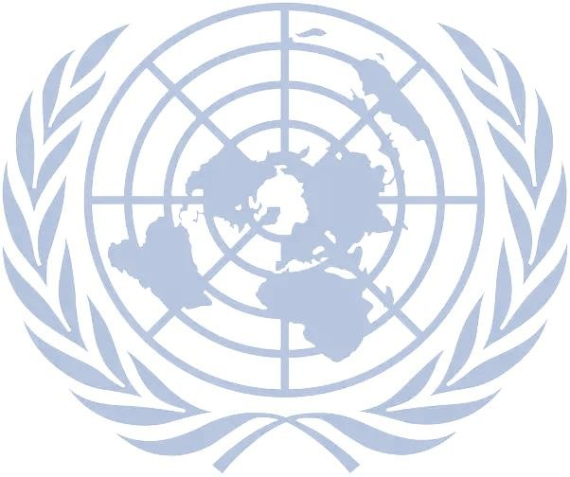
Website: www.un.org/Docs/sc/

ii. UNGA
Website: www.un.org/en/ga/

b. UN Affiliated bodies such as,
- The International Atomic Energy Agency (IAEA)
Website: www.iaea.org

- The World Bank (WB) Website: www.worldbank.org

ABOUT THE AGENDA
PREVENTION OF WAR BETWEEN THE US AND CHINA CONTEXT OF THE OUTBREAK OF CORONA VIRUS

‘It is clearly not a good time for the world and it is not a good time for relations between
the US and China.’

A sharp escalation of tensions over the handling of the pandemic has raised the spectre of a new Cold War. The relationship between the United States and

Will the US end up being seen as the victim of external forces or its own mismanagement? Will China end up being seen as the country that unleashed the virus or the one that showed the world how to overcome it?
China was already bad before the COVID-19 crisis. Distrust and animosity have
only grown in the past few weeks amidst the war on words over who is
responsible for the global pandemic. As the epidemic worsens, particularly in
the United States, so will the scapegoating and the narrative war. There is the
potential for US–China tension on COVID-19 to further fuel existing economic
and security tensions across the region, such as their trade war. Increased
tensions will make it harder for China and the United States to communicate
and cooperate effectively as is essential on this transnational threat. Of great
concern is the potential politicisation of the World Health Organization.

SUB AGENDAS:

General-
- Impact of trade on countries due to China- USA war and Covid 19.
- Alliance and side taking of different countries rather than uniting to fight against the virus.
- Constant allegations on social and political status of countries due to USA and China conflict.
- Impact on developing and poor countries due to covid-19 and USA and China war.
- "Uniting whole world to fight against corona virus rather than fighting each other" views of different countries.

  - Special and specific ones-
- Loopholes found by different countries to take sides and increasing the environment of war.
- Stopping the word war Between USA and China.
- World's health is more important than economic strength right now. Views.
- Impact of USA AND CHINA war on Islamic states.

